

**WIC2001 Advanced Network Technology**  
Faculty of Computer Science and Information Technology  
University of Malaya

**Lab Test Documentation**

**Prepared by**Muhammad Azri bin Zainuddin (WER150018)

Lecturer’s Name

Associate Prof. Dr. Ling Teck Chaw

**Physical Topology**

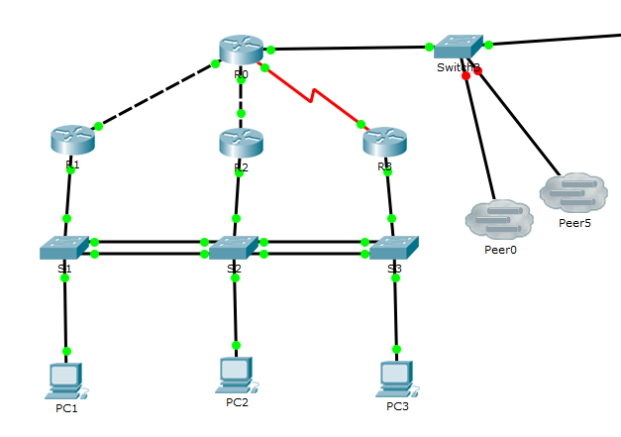

1. **Plan and record clearly Device names, Interfaces (include L0), IP addresses/subnet Mask, Default gateway and Switch port in the IP Addressing table below**

**IP Addressing Table**

|  |  |  |  |  |  |
| --- | --- | --- | --- | --- | --- |
| **Device/ Vlan/ Area** | **Interface** | **IP Address** | **Subnet Mask** | **Default Gateway** | **Switch Port** |
| **PC1** | Fa0 | 138.16.11.11 | 255.255.255.0 | 138.16.11.254 | Fa0/1 |
| 2001:138:16:11::11/64 | - | 2001:138:16:11::/64 |
|  | | | | | |
| **PC2** | Fa0 | 138.16.12.12 | 255.255.255.0 | 138.16.12.254 | Fa0/1 |
| 2001:138:16:12::12/64 | - | 2001:138:16:12::/64 |
|  | | | | | |
| **PC3** | Fa0 | 138.16.13.13 | 255.255.255.0 | 138.16.13.254 | Fa0/1 |
| 2001:138:16:13::13/64 | - | 2001:138:16:13::/64 |
|  | | | | | |
| **VLAN 161** | - | 138.16.11.161 | 255.255.255.0 | - | - |
| 2001:138:16:11::161/64 | - |
| **VLAN 162** | - | 138.16.12.162 | 255.255.255.0 | - | - |
| 2001:138:16:12::162/64 | - |
| **VLAN 163** | - | 138.16.13.163 | 255.255.255.0 | - | - |
| 2001:138:16:13::163/64 | - |
|  | | | | | |
| **R0** | Lo0 | 138.16.10.250 | 255.255.255.255 | - | - |
| 2001:138:16:FF::/128 | - |
| Gig0/0 | 74.33.21.16 | 255.255.255.0 | - | - |
| 2001:138:F::16/64 | - |
| FE80::16 (link local) | - |
| Gig0/1 | 138.16.255.1 | 255.255.255.252 | - | - |
| 2001:138:16:F::/127 | - |
| Gig0/2 | 138.16.255.5 | 255.255.255.252 | - | - |
| 2001:138:16:F::2/127 | - |
| S0/0/0 | 138.16.255.9 | 255.255.255.252 | - | - |
| 2001:138:16:F::4/127 | - |
|  | | | | | |
| **R1** | Lo0 | 138.16.10.251 | 255.255.255.255 | - | - |
| 2001:138:16:FF::1/128 | - |
| Gig0/0.1 | 138.16.11.254 | 255.255.255.0 | - | Fa0/4 |
| 2001:138:16:11::/64 | - |
| Gig0/0.2 | 138.16.12.254 | 255.255.255.0 | - | Fa0/4 |
| 2001:138:16:12::/64 | - |
| Gig0/0.3 | 138.16.13.254 | 255.255.255.0 | - | Fa0/4 |
| 2001:128:16:13::/64 | - |
| Gig0/1 | 138.16.255.2 | 255.255.255.252 | - | - |
| 2001:138:16:F::1//127 | - |
|  | | | | | |
| **R2** | Lo0 | 138.16.10.252 | 255.255.255.255 | - | - |
| 2001:138:16:FF::2/128 | - |
| Gig0/0.1 | 138.16.11.254 | 255.255.255.0 | - | Fa0/4 |
| 2001:138:16:11::/64 | - |
| Gig0/0.2 | 138.16.12.254 | 255.255.255.0 | - | Fa0/4 |
| 2001:138:16:12::/64 | - |
| Gig0/0.3 | 138.16.13.254 | 255.255.255.0 | - | Fa0/4 |
| 2001:128:16:13::/64 | - |
| Gig0/1 | 138.16.255.6 | 255.255.255.252 | - | - |
| 2001:138:16:F::3//127 | - |
|  | | | | | |
| **R3** | Lo0 | 138.16.10.253 | 255.255.255.255 | - | - |
| 2001:138:16:FF::3/128 | - |
| Gig0/0.1 | 138.16.11.254 | 255.255.255.0 | - | Fa0/4 |
| 2001:138:16:11::/64 | - |
| Gig0/0.2 | 138.16.12.254 | 255.255.255.0 | - | Fa0/4 |
| 2001:138:16:12::/64 | - |
| Gig0/0.3 | 138.16.13.254 | 255.255.255.0 | - | Fa0/4 |
| 2001:128:16:13::/64 | - |
| S0/0/1 | 138.16.255.10 | 255.255.255.252 | - | - |
| 2001:138:16:F::5/127 | - |

1. **Configure OSPF**

**R0**

ipv6 unicast-routing

R0(router)# router ospf 16

network 138.16.255.0 0.0.0.3 area 16

network 138.16.255.4 0.0.0.3 area 16

network 138.16.255.8 0.0.0.3 area 16

ipv6 router ospf 16

int g0/1

ipv6 ospf 16 area 16

**R1**

ipv6 unicast-routing

router ospf 16

passive-interface g0/0.1

passive-interface g0/0.2

passive-interface g0/0.3

network 138.16.11.0 0.0.0.255 area 16

network 138.16.255.0 0.0.0.3 area 16

network 138.16.12.0 0.0.0.255 area 16

network 138.16.13.0 0.0.0.255 area 16

ipv6 router ospf 16

int g0/1

ipv6 ospf 16 area 16

int g0/0.1

ipv6 ospf 16 area 16

int g0/0.2

ipv6 ospf 16 area 16

int g0/0.3

ipv6 ospf 16 area 16

**R2**

ipv6 unicast-routing

router ospf 16

passive-interface g0/0.1

passive-interface g0/0.2

passive-interface g0/0.3

network 138.16.12.0 0.0.0.255 area 16

network 138.16.255.4 0.0.0.3 area 16

network 138.16.11.0 0.0.0.255 area 16

network 138.16.13.0 0.0.0.255 area 16

ipv6 router ospf 16

int g0/1

ipv6 ospf 16 area 16

int g0/0.1

ipv6 ospf 16 area 16

int g0/0.2

ipv6 ospf 16 area 16

int g0/0.3

ipv6 ospf 16 area 16

**R3**

ipv6 unicast-routing

router ospf 16

passive-interface g0/0.1

passive-interface g0/0.2

passive-interface g0/0.3

network 138.16.13.0 0.0.0.255 area 16

network 138.16.255.8 0.0.0.3 area 16

network 138.16.11.0 0.0.0.255 area 16

network 138.16.12.0 0.0.0.255 area 16

ipv6 router ospf 16

int g0/1

ipv6 ospf 16 area 16

int g0/0.1

ipv6 ospf 16 area 16

int g0/0.2

ipv6 ospf 16 area 16

int g0/0.3

ipv6 ospf 16 area 16

1. **Configure EIGRP and publish only summarized address**

**R0**

router eigrp 2001

network 74.33.21.0 0.0.0.255

network 138.16.0.0 0.0.15.255

ipv6 router eigrp 2001

no shut

ip summary-address eigrp 2001 138.16.0.0 255.255.240.0.5

int lo0

ipv6 eigrp 2001

int g0/0

ipv6 eigrp 2001

ipv6 summary-address eigrp 2001 2001:138:16::/48

1. **Redistribute routes between EIGRP and OSPF**

**R0**

router ospf 16

redistribute eigrp 2001 metric 10 metric-type 1 subnets

ipv6 router ospf 16

redistribute eigrp 2001 metric 10 metric-type 1

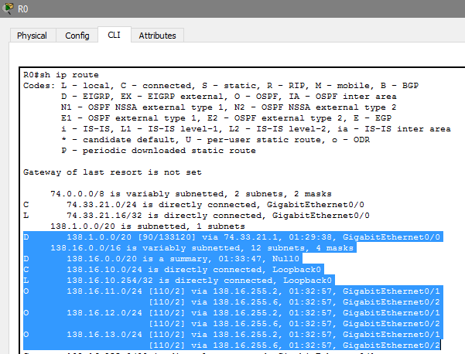

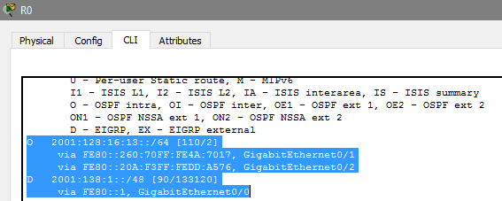

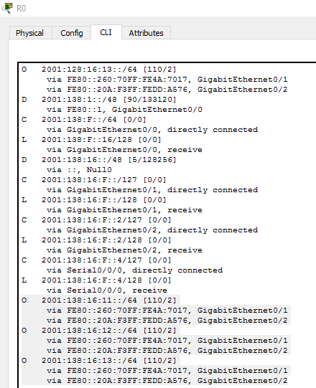

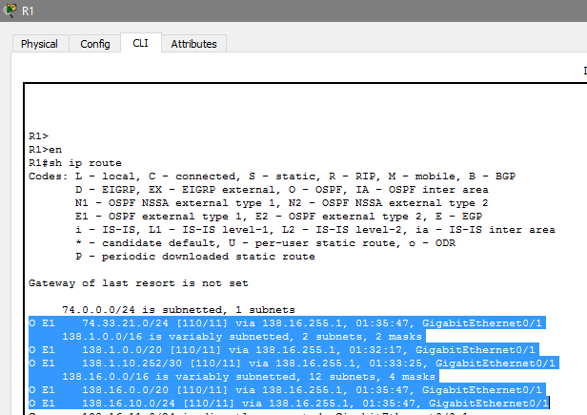

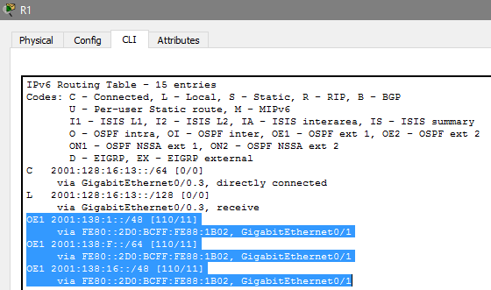

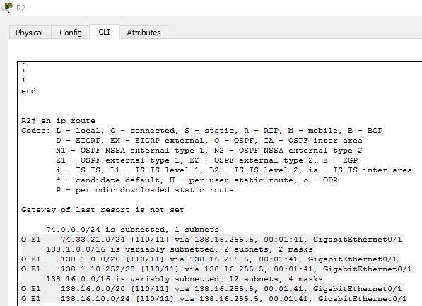

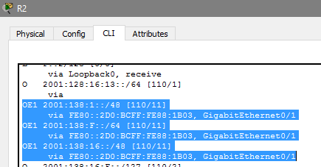

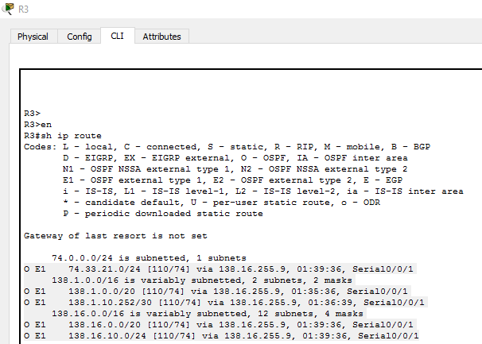

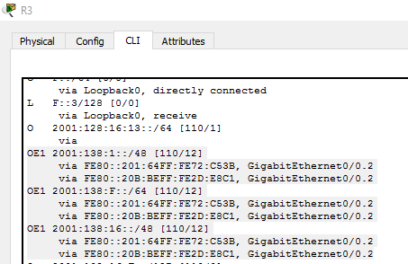

1. **Configure EtherChannel**

**S1**

int fa0/2

switchport mode trunk

channel-group 1 mode active

int fa0/3

switchport mode trunk

channel-group 1 mode active

**S2**

int fa0/2

switchport mode trunk

channel-group 1 mode active

int fa0/3

switchport mode trunk

channel-group 1 mode active

int fa0/5

switchport mode trunk

channel-group 2 mode desirable

int fa0/6

switchport mode trunk

channel-group 2 mode desirable

**S3**

int fa0/2

switchport mode trunk

channel-group 1 mode desirable

int fa0/3

switchport mode trunk

channel-group 1 mode desirable

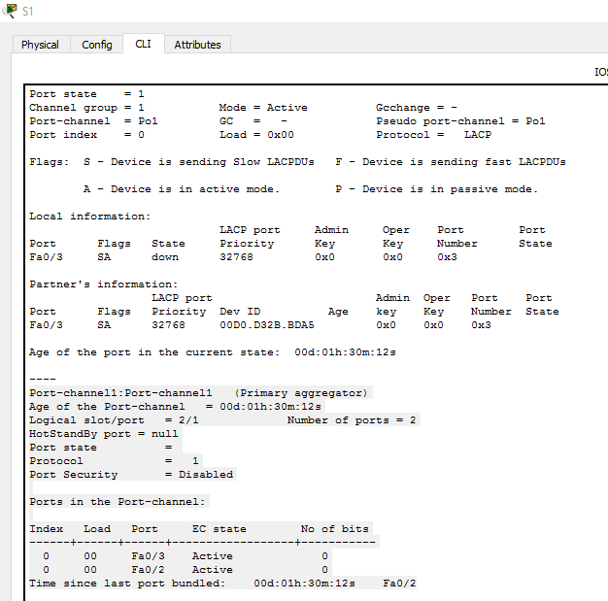

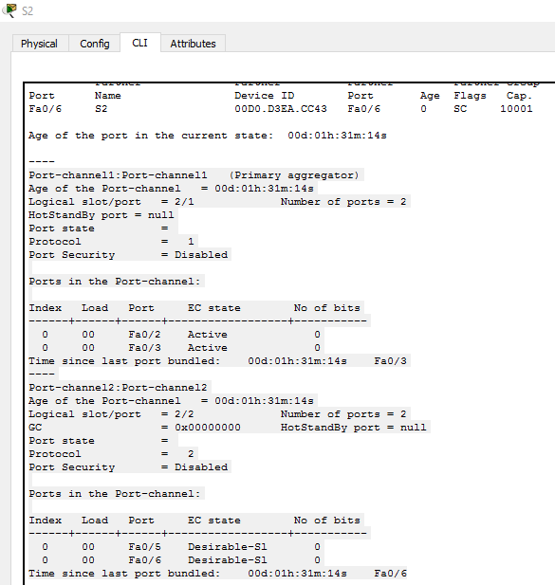

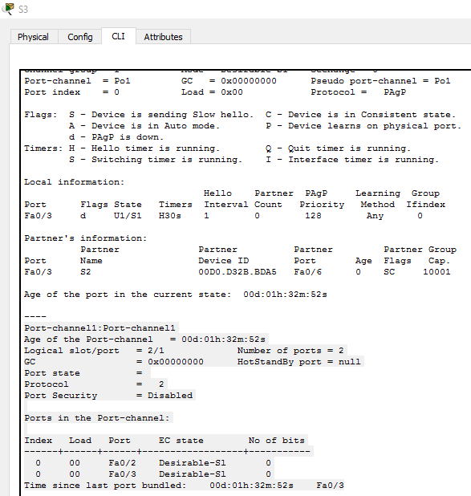

1. **Configure VTP and PVSTP+**

**S1**

vtp domain test

vtp mode client

spanning-tree mode pvst

spanning-tree vlan 161 priority 24576

**S2**

vtp domain test

vtp mode server

spanning-tree mode pvst

spanning-tree vlan 162 priority 24576

**S3**

vtp domain test

vtp mode client

spanning-tree mode pvst

spanning-tree vlan 163 priority 24576

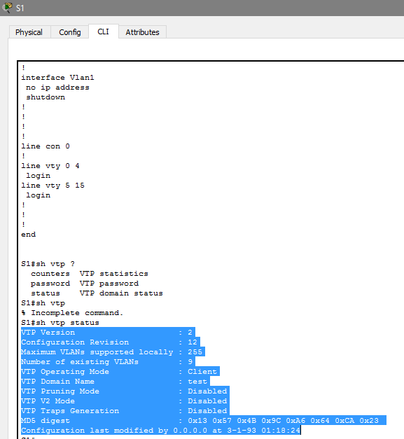

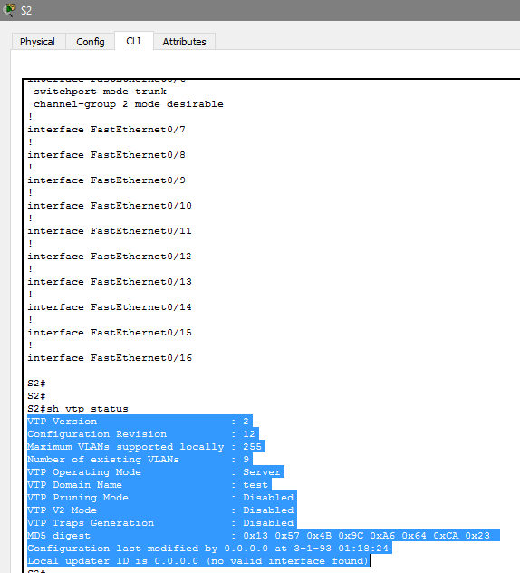

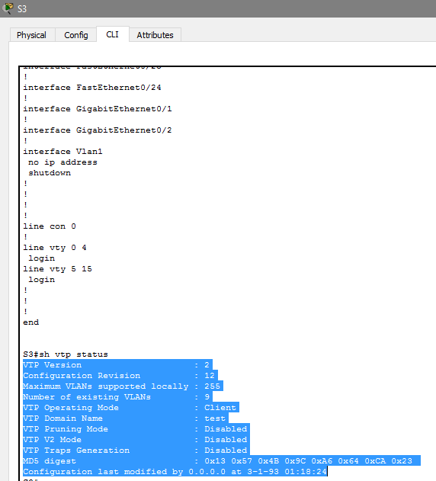

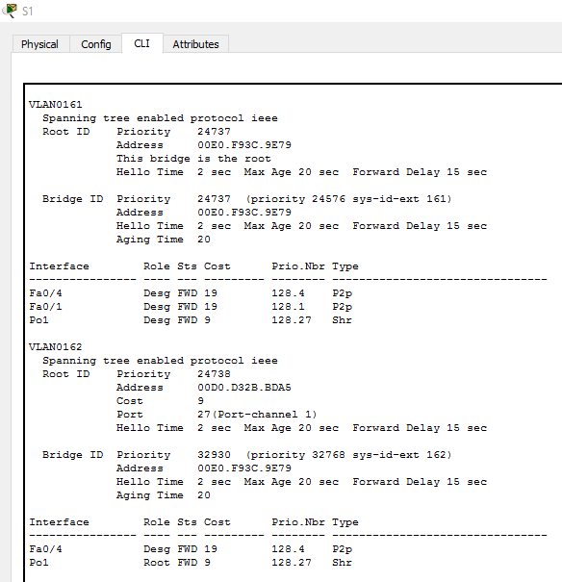

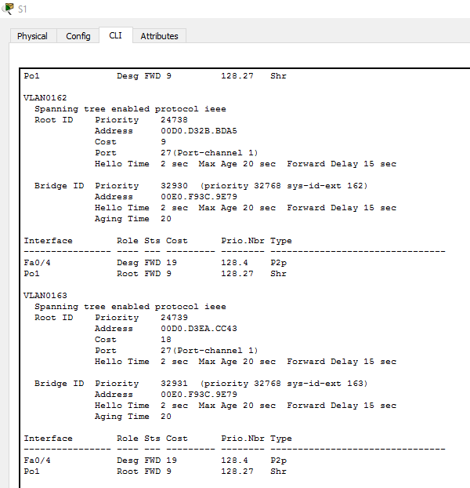

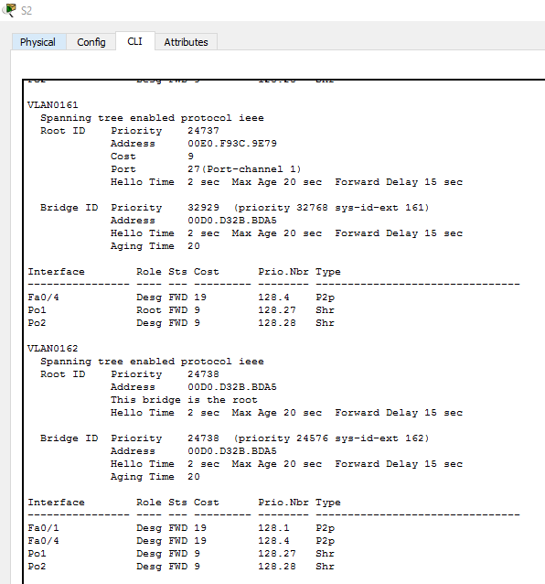

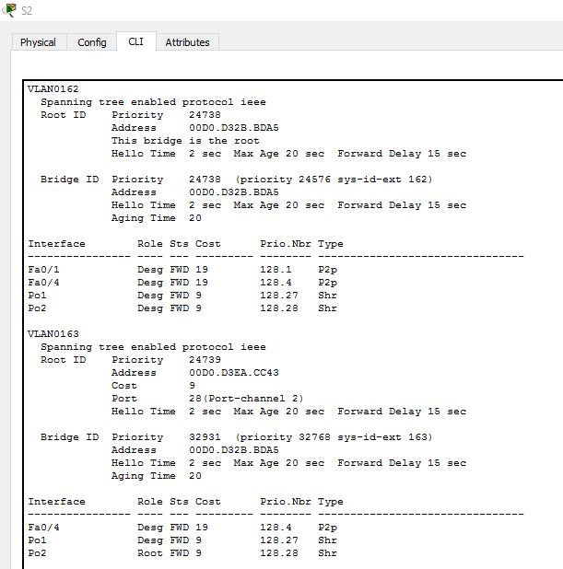

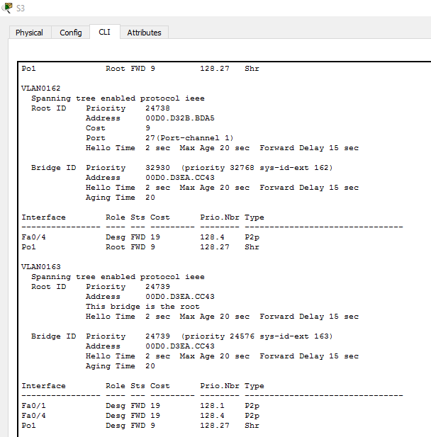

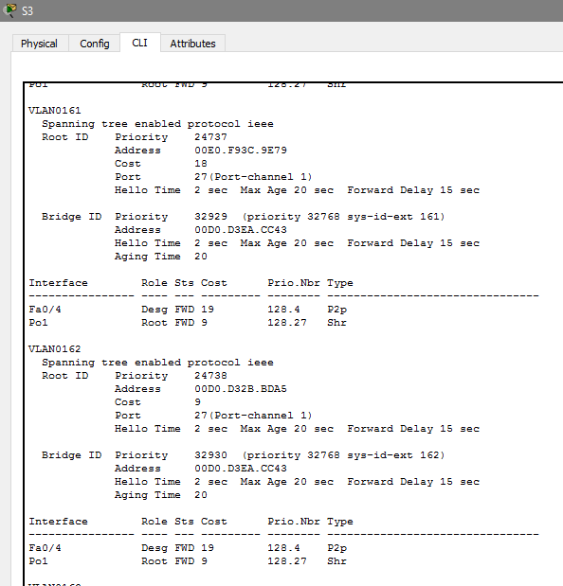

1. **Configure HSRP (3 marks)**

**R1**

int g0/0.1

encapsulation dot1Q 161

ip address 138.16.11.254 255.255.255.0

ipv6 address 2001:138:16:11::/64

ipv6 ospf 16 area 16

standby 1 ip 138.16.11.253

standby 1 priority 150

standby 1 preempt

standby 1 track GigabitEthernet0/1

int g0/0.2

encapsulation dot1Q 162

ip address 138.16.12.254 255.255.255.0

ipv6 address 2001:138:16:12::/64

ipv6 ospf 16 area 16

standby 2 ip 138.16.12.253

standby 2 track GigabitEthernet0/1

int g0/0.3

encapsulation dot1Q 163

ip address 138.16.13.254 255.255.255.0

ipv6 address 2001:128:16:13::/64

ipv6 ospf 16 area 16

standby 3 ip 138.16.13.253

**R2**

int g0/0.1

encapsulation dot1Q 161

ip address 138.16.11.254 255.255.255.0

ipv6 address 2001:138:16:11::/64

standby 1 ip 138.16.11.253

standby 1 track GigabitEthernet0/1

int g0/0.2

encapsulation dot1Q 162

ip address 138.16.12.254 255.255.255.0

ipv6 address 2001:138:16:12::/64

ipv6 ospf 16 area 16

standby 2 ip 138.16.12.253

standby 2 priority 150

standby 2 preempt

standby 2 track GigabitEthernet0/1

int g0/0.3

encapsulation dot1Q 163

ip address 138.16.13.254 255.255.255.0

ipv6 address 2001:138:16:13::/64

ipv6 ospf 16 area 16

standby 3 ip 138.16.13.253

**R3**

int g0/0.1

encapsulation dot1Q 161

ip address 138.16.11.254 255.255.255.0

ipv6 address 2001:138:16:11::/64

ipv6 ospf 16 area 16

standby 1 ip 138.16.11.253

standby 1 track Serial0/0/1

int g0/0.2

encapsulation dot1Q 162

ip address 138.16.12.254 255.255.255.0

ipv6 address 2001:138:16:12::/64

ipv6 ospf 16 area 16

standby 2 ip 138.16.12.253

standby 2 track Serial0/0/1

int g0/0.3

encapsulation dot1Q 163

ip address 138.16.13.254 255.255.255.0

ipv6 address 2001:138:16:13::/64

ipv6 ospf 16 area 16

standby 3 ip 138.16.13.253

standby 3 priority 150

standby 3 preempt

standby 3 track Serial0/0/1